l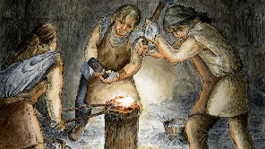 | Year: 3 Term: 2 Topic: Iron Age  In Term 2, students will explore life in Iron Age Britain, learning about its people, tools, and communities. In Science, they will investigate forces and magnets, discovering how objects move and how magnets attract or repel each other.
 | Big Bang: Journey to the Iron Age  Our Big Bang project will take place on Friday, 15th November 2024. The children will spend the afternoon travelling back in time to the Iron Age, taking part in fun, hands-on activities to explore what life was like during this period | Trip:  Whole school trip to Planet Ice on Monday 24th November 2025.
 | Our Learning Overview
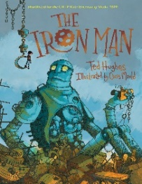  Iron Age |  |  | Key Text  Please read with your child every day and record this in their reading record.  TTRS should also be daily 3-5 minutes.  5 Spelling Bee will also be set weekly.  Spruce class PE day  Tuesday and Thursday  Key dates:  Friday 15th November – Big Bang day  Tuesday 11th November – Individual photos  Wednesday 19th November – Parents Evening  Thursday 20th November – Parents evening  Friday 21st November – Tombola Tag Day  Monday 24th November – Planet Ice Trip  Thursday 4th December – Christmas fair  Wednesday 10th December – Christmas Dinner  Thursday 11th December – Christmas Shop (PTFA)  Tuesday 16th December KS2 Christmas concert  Friday 19th December – End of term
  English |  | In English, we will be reading The Iron Man and using it as inspiration to write detailed character descriptions and imaginative poems that explore the voices and themes of the story.
  Maths |  | In Maths, our focus this term is on strengthening skills in addition and subtraction, where students will practice techniques to solve problems accurately and efficiently.
  Science |  | In Science, our lessons will explore forces and magnets, allowing students to investigate magnetic properties and understand how various forces affect movement.
  History |  | In History, we will journey back to the Iron Age, where we will learn about life, technology, and societal changes during this fascinating period. Our key question in history this term is If you could spend a week living in an Iron Age village, what would you enjoy the most and why?
  History | DTTD
  DT | DTTD | In Design and Technology (DT),Students will be designing and making Christmas biscuits, focusing on designing for a customer and developing key skills in measurement, baking, and food decoration.
  RE |  | In RE, our key question for this term is: What kind of world do Christians believe Jesus wanted? We will look at what kind of world Jesus envisioned, focusing on his teachings about love and kindness
  PSHE  Music |  | In PSHE, our focus will be on Celebrating Differences, encouraging students to appreciate diversity and respect individuality within their community.  In Music, this term, the children will explore rhythmic patterns with body percussion, instruments, learn call-and-response techniques, and sing songs from various styles.

