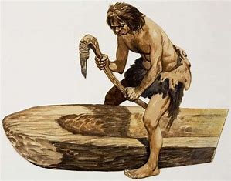 | Year: 3 Term: 1 Topic: Stone Age  In Term 1, students will embark on an exciting journey to explore the Stone Age, focusing on family life, homes, tools, food, and how people lived and survived during this fascinating period. In Science, we will be learning all about rocks and soils, discovering their properties and how they form.
 | Big Bang: Stone Age quest  Our Big Bang project will take place on Friday 5th September 2025. The day will focus on the Stone Age, with a fun interactive lesson and a quiz in the morning, followed by a clay activity where children will create their own Stone Age houses. | Trip:  N/A
 | Our Learning Overview
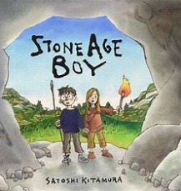  Our Topics | In French, our topic is Getting to Know You. Students will learn basic greetings, how to exchange names, count to 10, and say their age.  French |  | Homework  Year 3 homework  TTRS – daily (3 minutes a day)  Spelling Shed - 4 times a week  Reading - daily  Key dates:  Year 3 Big Bang – Friday 5th September 2025  Meet the teacher – 11th September 2025  KS2 Harvest – 14th October  Last day of term – 14th February 2025  Key information:  Spruce class PE day  Tuesday – indoor PE  Thursday – Outdoor PE
  English |  | In English, we will be reading The Stone Age Boy this term. The children will write a setting description based on the boy’s adventure, focusing on using a range of descriptive techniques to bring the Stone Age setting to life.
  Maths |  | In Maths, our focus this term is on place value, concentrating on understanding the value of each digit in three-digit numbers, comparing and ordering numbers, and developing confidence in using number lines and partitioning.
  Science |  | In Science, our lessons will explore rocks and soils. Children will compare and group different types of rocks based on their appearance and properties, learn how fossils are formed, and understand how soil is made.
  History |  | In History, we will be learning about the Stone Age, exploring family life, homes, tools, food, and how people lived and survived. Children will use their knowledge to answer our big question: “Would you want to be part of a Stone Age tribe?”
  History | DTTD
  Art | DTTD | In Art, students will focus on the artist Joan Miró, exploring his unique style and the different types of art he created. They will study his work and experiment with similar techniques to inspire and develop their own creative pieces.
  RE |  | In RE, we will be learning about why Christians follow God, the values Jesus taught that guide their lives and the importance of prayer as a way for Christians to communicate with God.
  PSHE |  | In PSHE, we will focus on Being Me in My World. Children will learn to recognise their worth, understand and manage their feelings, make others feel welcome, and work together to create a positive and caring classroom community.

