

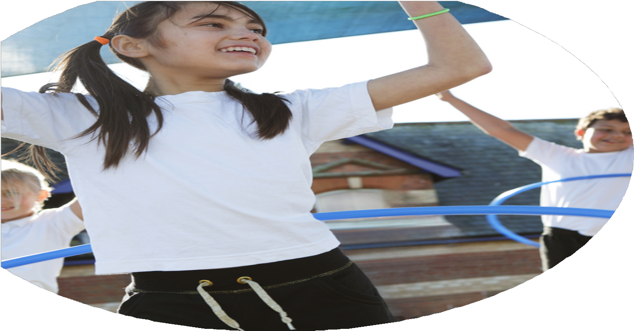
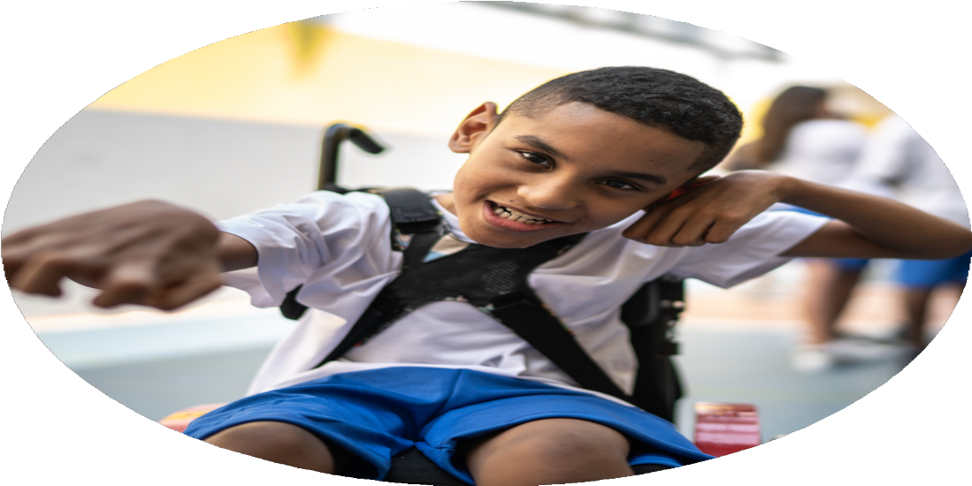




PE Funding

Evaluation Form

Commissioned by

Created by

Images courtesy of Youth Sport Trust

PE Funding Evaluation Form

It is intended that this template should be used as preparation for the completion of the statutory digital reporting tool being introduced this academic year. You can upload data (including swimming) from this template onto this platform once it becomes accessible.
Before you decide how you are going to use the funding for this academic year you should reflect and evaluate the impact of your use of the funding in 2023/24.
All spending of the funding must conform with the terms outlined in the Conditions of Grant document. The template is a working document that you can amend/update during the year.
Based on your evaluation of last year’s funding you should decide what you intend to do this academic year, how you will do it, and what impact you expect it to have.

It is important that the funding is used effectively and based on your school’s needs.
You must use the funding to make additional and sustainable improvements to the PE and sport in your school. You must develop and add to the PESSPA activities that your school already offers.

Summative digital reporting from June 2025 will continue to include swimming and water safety information therefore funding can be used to provide top-up lessons where necessary to ensure pupils meet national curriculum swimming requirements.

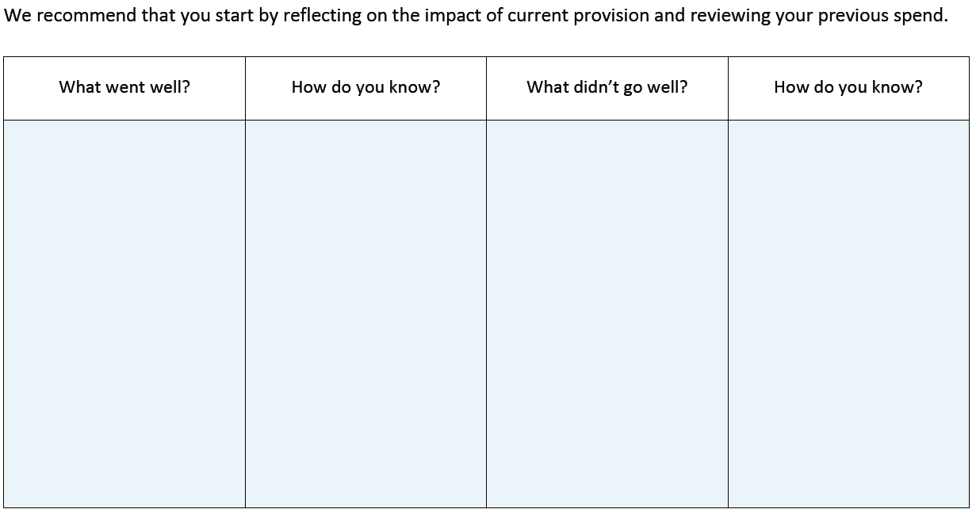
- Some staff still had little subject knowledge

- Lack of leaders on the playground

- Lack of competitiveness from some

- No competitions entered
- Longer support for some staff. Some only had 4 lessons

- Some children lost enthusiasm for leading after a while

- Some children didn’t like the thought of competition

- Lack of competition for Years 1 - 4
- PE specialist delivered support to all staff

- Training for 12 Year 5 and 6 children. Caps worn. Playground games improved

- Children in house teams – more competitive.
- Introduction of curriculum support

- Introduction of Sports Leaders

- Introduction of house teams. Sports day was the first event in house teams

What are your plans for 2024/25?

Intent
How are you going to action and achieve these plans?

Implementation
- Increase in competition – Intra House for all in Years 1 – 6

- Increase in Inter School competition – Years 1 – 6

- Team teaching with ECT

- Increase participation levels in all children, as well as our SEND children

- CPD for staff

- To involve our families in more active events and more active travel

- PE lessons to be more structured and engaging

- Improvement of PE kit and raising the profile of PE
- Termly competitions – Multi Skills, Racket Skills, Dodgeball, 4 Ball Rounders, Rapid Fire Cricket and Sports Day. House T-shirts, winners trophies and house captains were introduced

- Mini Youth Games, Howard School Sports Greenacre School Sports Partnership, Cross Country Races and Disability Youth Games

- 2 x 6 week block of support. 1 block indoor PE. 1 block outdoor PE

- After school clubs for MYG and DYG, Community lead coaching and staff led clubs. Wheelchair Basketball, skiing, inclusive tennis and summer games

- Staff are encouraged to attend PE and sport related CPD. JT – Cricket, MC – Tennis, CM – Swimming, all staff – Gymnastics, staff in years 3-6 – team teaching swimming with a qualified instructor and MD – Basketball team teaching with a community coach

- Family sports afternoon – an afternoon with 9 community clubs showcasing their sport for families to join in. New bike racks. WOW walking scheme

- The introduction and continuation of Complete PE

- Children will wear their PE kits to school. Huge improvement in every class on the amount of children wearing correct PE kit

What impact/intended impact/sustainability are you
expecting?
How will you know? What evidence do you have or
expect to have?
- Registers

- Registers

- Number of clubs now on offer and registers

- 100% of children now take part every term. See competitions timetable

- 100% of staff had external Gymnastics CPD. 4 other members of staff had extra sport CPD

- 100% of teachers, TA’s and Leadership had PE inset on making our school more active. Schemes of work to include movement breaks and physical activities

- 94% of children walk to school. 2nd place in the Living Streets WOW competition. 1st place in the Sustrans Walk to School competition

- Observations by Leadership and PE Specialist. Minimal amount of children not wearing PE kit. The introduction of children now wearing PE kit to school has helped.
- Number of children taking part in competitions has increased

- Number of SEND and PP children taking part in comps has increased

- Number of children attending after school clubs has increased

- Number of children taking part in termly Intra House competitions has increased

- CPD for staff

- Staff Inset in PE

- More children are walking or parking and striding to school

- Children wearing correct PE kit and joining in lessons

What impact/sustainability have you seen?
What evidence do you have?
- We will track numbers

- To run SEND and PP only clubs

- Continue to enter all competitions next year

- To continue with all 6 Intra House competitions next year

- More children joining in all PESSPA events
- Number of after school clubs to increase next year. More clubs for children in Years 1 – 4

- To increase the number of SEND PE clubs for the children to take part in

- The number of children attending Inter School competitions to same the same or raise a little higher

- To continue to have ever child taking part in Intra School competitions

- Improvement in PE kits and kits worn to competitions, raising the profile of PE and School Sport further

