Art & Design Twydall Primary School

Aim
- Basic skills are introduced and then built upon, including drawing, sketchbooks, painting, printmaking and sculpture
- Skills are revisited and the use of ongoing sketchbook work underpins this process.
- We believe in fostering an open-ended exploration of creativity and that the journey to a final outcome just as (if not more) important than the outcome itself.
- By creating a safe and nurturing environment, pupils are encouraged to take creative risks, develop an individual style and to learn from the journey, rather than head towards a pre-defined end result.
- Through discussions and critiques of artists work, children will constantly be exposed to technical vocabulary and should be encouraged to use it when talking about their own and others work.
- Children will plan and create final responses influenced by each termly artist. These outcomes can be linked and influenced by other areas of the curriculum (like their current topic or a book they are studying)
- Children will fill a sketchbook each year and understand that every page (even the research pages) should look like artworks in their own right.

By the end of their time at Twydall Primary School, our pupils will have a deep knowledge of current and historical artists from a range of movements, media and cultural backgrounds. They will have a wide artistic vocabulary and be able to verbalise opinions about theirs and others work, using the correct terminology. They will understand how to keep a sketchbook and use it to develop their own work and to research influential artists as well as explore new techniques and ideas.

How it works:
Each term is broken into 6 lessons (as a guide). These can be adapted for longer or shorter terms where necessary. It would also be encouraged for all years to do at least one Art ‘BIG BANG’ within the school year in order to give the children plenty of time to explore their new artists style, develop their ideas and have an opportunity to create a ‘Gallery’ to showcase their work to an audience.

The 6 lessons:

- Research – The first lesson is used to introduced the new artist (or concept) What skills will they be learning, what materials will they be using and how will they showcase these new skills in their final outcome?

The children should be given a brief background into the artist – their life, are they still living? Where in the world they are from? their background story, how they got into art, why they got into art, were they famous when they were living (if dead) or are they famous now they are no longer around, did they start a movement? what was happening at the time? etc.
Discuss the artwork – What can you see? What do you think about it? What materials are used? How does it make you feel? How long do you think it took? What is your interpretation on the work? Do you like it? Why/why not?
Outcome – Children create a research page about the artist/designer, trying to decorate the page in the same/similar style. Children should be provided with pictures to cut and stick in order to support this part of the work.
This part of the journey through the sketchbook is about building a picture of the artist/designer, their style and what they are about. A collage of pictures built up through research.

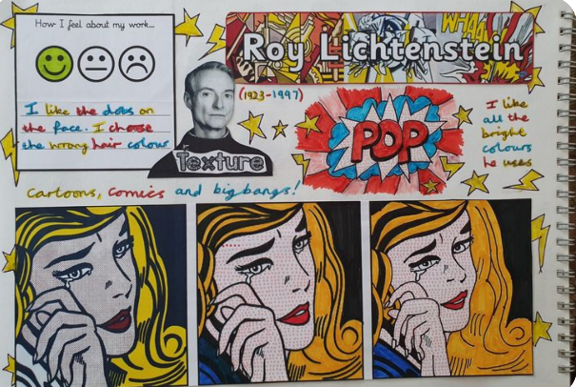
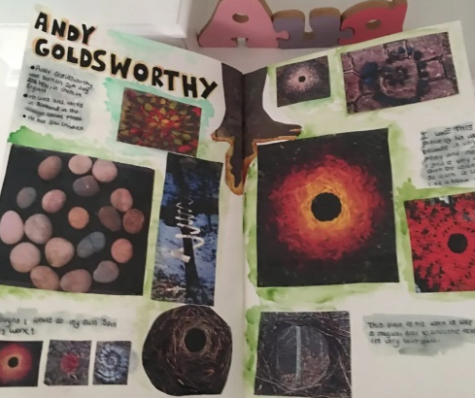

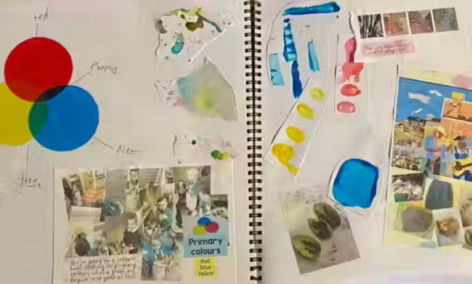
- Replicate – In this next lesson, children are given an opportunity to try and recreate a piece of work by the artist. This should give them a real feel for the work, without the pressure of coming up with an idea first. This page allows the children to begin to get a feel for the material they are using, the techniques that may be involved and the opportunity to allow them to express their artistic skills through the style of a focused artist, designer or concept.

Where appropriate, this page can be completed by the use of photographs stuck into the sketchbook showcasing the children’s replicas of their artists/designer or art concept that may have been done through sculpture, wall murals etc outside of their sketchbooks.
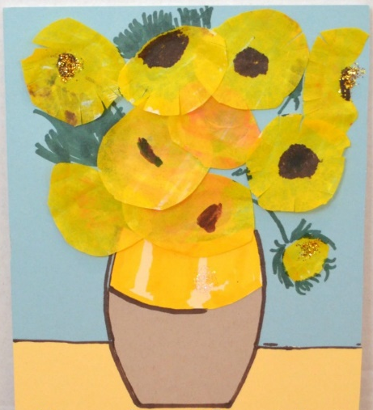
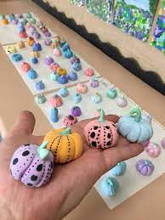
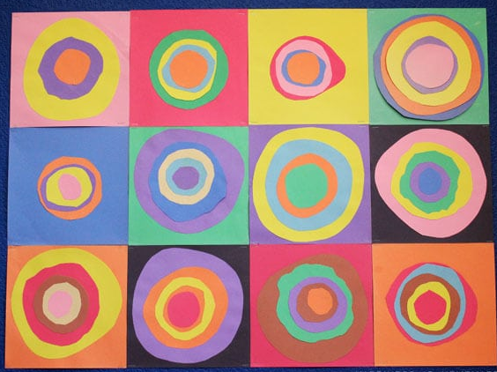

(a whole afternoon would be a great opportunity for the ‘experiment’ stage of the lesson or stretched over two weeks if possible)

- Experiment – This lesson is for children to explore the artist/designer’s style without restriction of an idea. Its important that these pages are used to express their understanding of the style that is being used, experiment with the focused material(s) and use them as a practise to learn the new skills being taught. For example, if studying the artist Henry Moore these experiment pages could be filled with weird and wonderful abstract shapes, showcasing the use of ripped paper, crayons pastels and paints to create abstract shapes. You could then experiment with plasticine, creating miniature sculptures in Moores’ artistic style only to take a photograph and then squish the plasticine back to its original state and try something else.

These pages should be jam packed of evidence from the children showcasing the skills being taught. It could be that the pages are jam packed with swirls and dabs (for Van Gough) or lots of plant-like cut outs (for Matisse) or a whole page of blue and green watercolours (for Monet). This lesson is lots of fun for the children as its an opportunity to experiment with their new-found knowledge and skills based around their target focus. The only aim is to get to know and practise the style of the artist and to get used to the medium they are using.

This is a great opportunity to walk around and ensure the children understand the style of the artists, stretching and challenging the children, asking questions such as ‘why did you use that colour/.’ ‘Did Picasso use shapes like that?’ ‘What does that symbolise?’ etc.

Have fun!

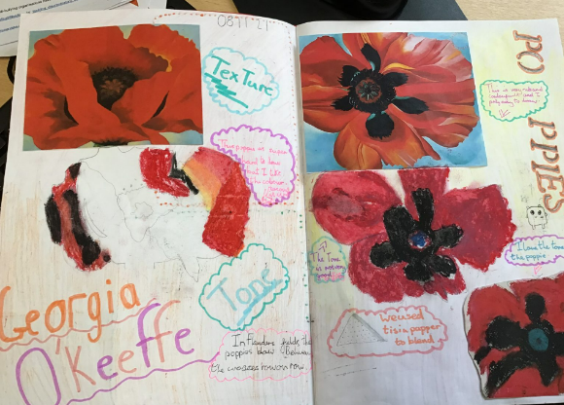
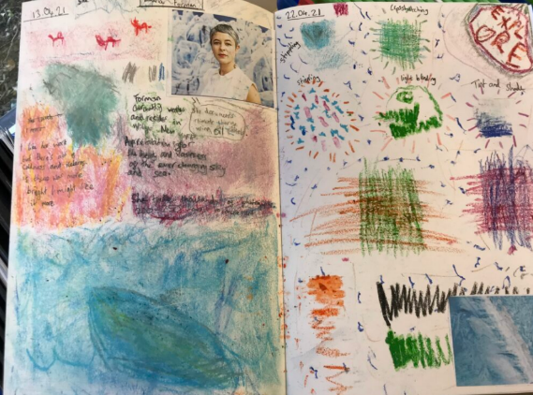
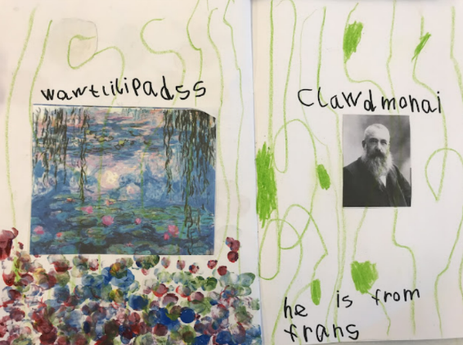

- Ideas – This lesson begins to show the children’s ideas develop for their final outcome and should also start to show their understanding of the skills learnt so far as well as the artist/ designers’ style. This is a great place to link in your current topic and should have more of a focus on the final outcome. Children should use an entire page/ double page to mind map their ideas. This could include specific skills used in a particular piece of art produced by the focused artist/designer that they like and want to try and use or a particular piece of artwork that has helped to inspire their final outcome. This page should mind map their understanding of what they have learnt so far and how they see all of the new-found skills and artist inspiration to support and develop their final outcome.

Once they have mapped out their thoughts and ideas (this could be in the form of little doodles, could include the use of swatches of materials, splashes of colour etc) they can begin creating idea thumbnails. (you could draw small boxes on the page and use these to create small, quick, rough ideas for their final outcome). These should be annotated to explain their concept.
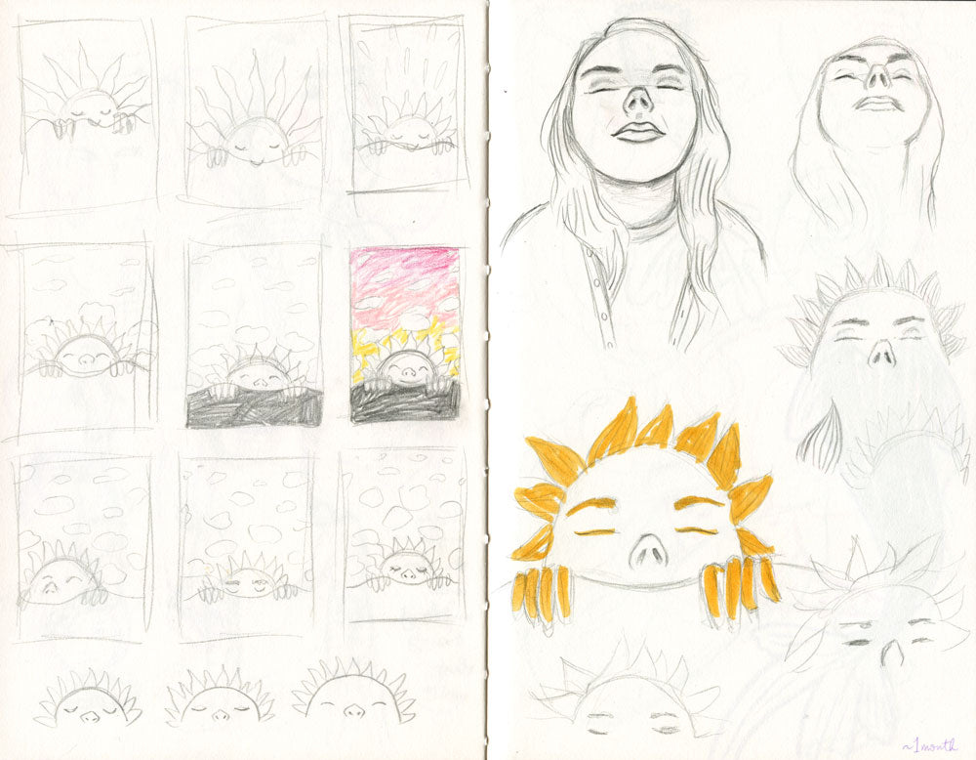

- Plan – Once the children have had a chance to explore ideas and create multiple small thumbnail designs and sketches, they should now pick their favourite one.
The focus on this page looks at their final outcome and how they plan to create this. On a double spread page (where appropriate) they will need to draw/sketch/label their final design and explain how they plan to create this, what materials and skills they will use and why they have chosen this as their final piece.

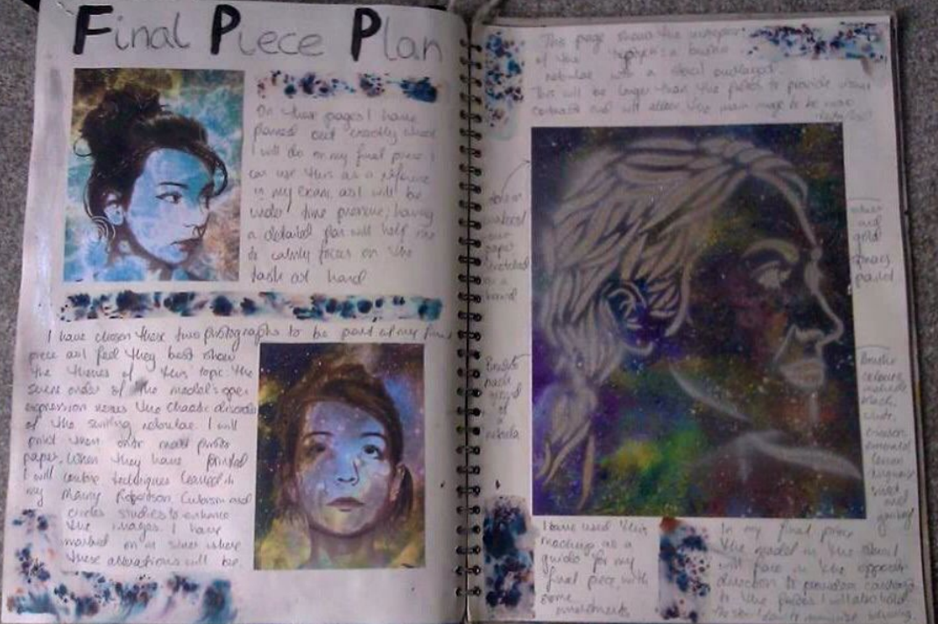
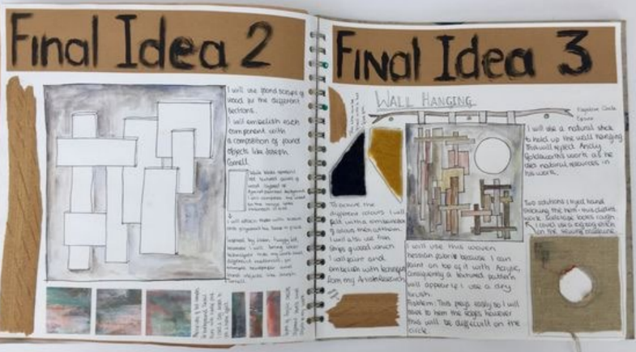

- Final piece – (self-explanatory)
Children use their final plan to create their final piece of artwork in the style of the focused artist/designer but conveyed using their own original idea that they have thought about and developed (this could be related to your class topic). A journey of ideas and experiments leading to the final outcome should be seen within the sketchbook.

Evaluate – Children should be given the opportunity to write up an evaluation based on the outcome of their final piece. How this looks and how much is involved is dependent on the year group. You can personalise this in a way that best suits your class.

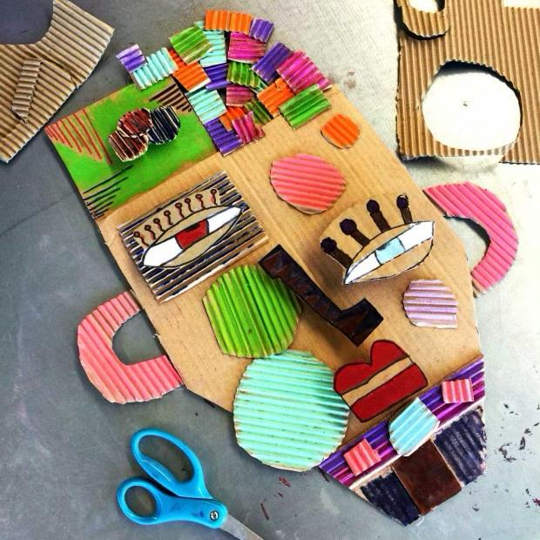
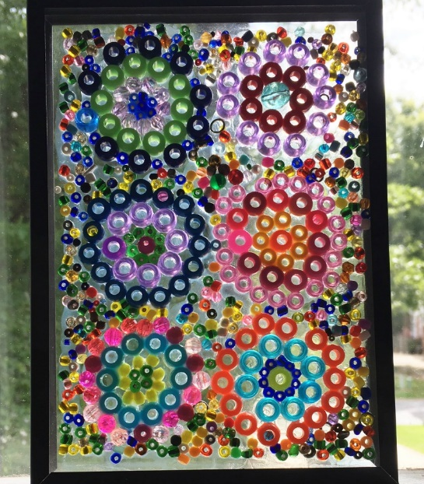
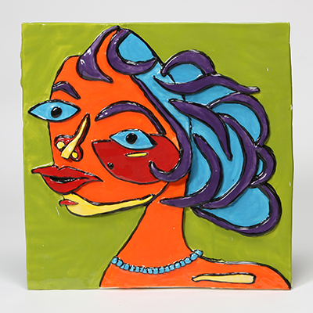
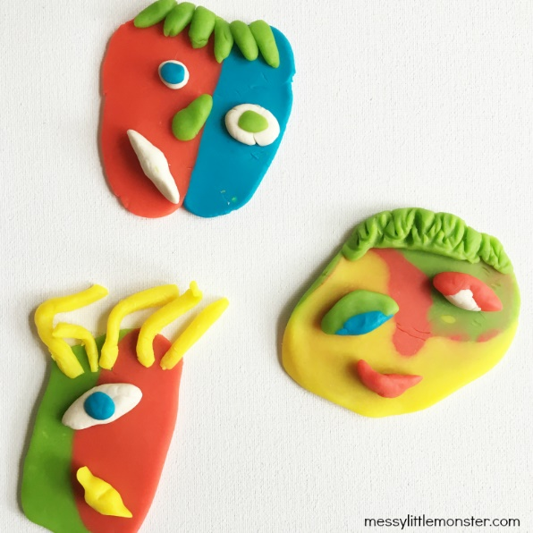

Vocabulary
Children do not need to know the exact definitions of the words found below but should be exposed to all of these words (and many more) throughout the course of the school year. A brief explanation of the word and the use of it as often as possible throughout your specific art project will help to do this.

Composition Symbolise Depict
Tone Medium Proportion
Colour palette Perspective Portray
Mood Realism Expressionism
Line Texture Abstract
Critique Surrealism Impressionism

Artists by year groups
 | Term A  (Autumn) | Term B  (Spring) | Term C  (Summer)
Year 1 | Janet Sobel  (Expressionism  Painting & printing) | Kandinsky  (Abstract  sketching & drawing) | Andy Goldsworthy  (Environmental  3D art)
Year 2 | Picasso  (Abstract  3D art) | Van Gough  (Mark-making/ Impressionism/ Painting & printing) | Henry Matisse  (drawing & sketching - portraits)
Year 3 | Joan Miro  (Surrealism  Painting & printing) | L.S. Lowry  (Architect/Landscapes  Sketching & drawing) | Quentin Blake  (illustrations – 3D art)
Year 4 | Gaudi  (Architecture  3D art) | Roy Lichtenstein  (Pop art  drawing & sketching) | Claude Monet  (Watercolours  Painting & printing)
Year 5 | Jade Purple Brown  (Illustrator, Designer, Creative direction  Painting & printing) | 'Sculpture’  (Jeff Koons/ Henry Moore/Barbara Hepworth/ Louise Bourgeois) | Frida Kahlo  (Self-portraits  Painting & printing)
Year 6 | Andy Warhol  (Pop Art  painting & printing) | Yayoi Kusama  (Japanese Artist  painting, sculpture and fashion) | 'Graffiti’  (Banksy/ Jean-Michel Basquiat/ Lady Pink)

Key Stage 1
NC
- to develop a wide range of art and design techniques in using colour, pattern, texture, line, shape, form and space
- to use drawing, painting and sculpture to develop and share their ideas, experiences and imagination
- to use a range of materials creatively to design and make products
Drawing & sketching (Y1)  - Draw lines of different sizes and thickness.  - Colour (own work) neatly following the lines.  - Show pattern and texture by adding dots and lines.  - Show different tones by using coloured pencils.  Painting & Printing (Y1)  - Use repeating or overlapping shapes.  - Mimic print from the environment (e.g. wallpapers).  - Use objects to create prints (e.g. fruit, vegetables or sponges).  - Press, roll, rub and stamp to make prints.  3-D Art (Y1)  - Use a combination of materials that are cut,  torn and glued.  - Sort and arrange materials.  - Mix materials to create texture. | Drawing & sketching (Y2)  - Build on understanding of tone by drawing light/dark lines  - Show pattern and texture by adding dots, lines and hatching.  - Choose different shades of colour to add light and dark.  Painting & Printing (Y2)  - Use thick and thin brushes.  - Mix primary colours to make secondary.  - Add white to colours to make tints and black to colours to make tones.  - Create colour wheels.  3-D Art (Y2)  - Use a combination of shapes.  - Include lines and texture.  - Use rolled up paper, straws, paper, card and clay as materials.  - Use techniques such as rolling, cutting,  moulding and carving.
NC
- about the work of a range of artists, craft makers and designers, describing the differences and similarities between different practices and disciplines, and making links to their own work
Artists research  • Respond to ideas and starting points by identifying what they like and dislike about art.  - Describe the work of notable artists, artisans and designers using vocabulary to describe basic colours and shape.  - Use some of the ideas of artists studied to create pieces.  • Explore ideas and collect visual information, discussing their learning.  • Explore different methods and materials as ideas develop.  Evaluation  - Say what they like about their work. | Artists research  • Respond to ideas and starting points by identifying what they like and dislike about art and giving reasons why.  - Describe the work of notable artists, artisans and designers using vocabulary to describe shades, shapes, lines and forms.  - Use some of the ideas of artists studied to create pieces, explaining what inspiration they have taken and why.  • Explore ideas and collect visual information, annotating with observations.  • Explore different methods and materials as ideas develop, giving reasons why they might favour one over another.  Evaluation  - Say what like and improvements they would make.

Key Stage 2
Yr 3 & 4
NC
- to create sketch books to record their observations and use them to review and revisit ideas
- to improve their mastery of art and design techniques, including drawing, painting and sculpture with a range of materials [for example, pencil, charcoal, paint, clay]
- about great artists, architects and designers in history
Drawing & sketching (Y3)  - Use different harnesses of pencils to show line, tone and texture.  - Sketch lightly to map out initial shape and form.  - Use shading to show light and shadow.  - Use hatching and cross hatching to show tone and texture.  Painting & Printing (Y3)  - Use a number of brush techniques using thick  and thin brushes to produce shapes, textures,  patterns and lines.  - Mix colours effectively.  - Use watercolour paint to produce washes for  backgrounds then add detail.  - Experiment with creating mood with colour.  3-D Art (Y3)  - Select and arrange materials for a striking  - effect.  - Ensure work is precise.  - Use coiling/overlapping/ tessellation/mosaic and/or montage. | Drawing & sketching (Y4)  - Use layers of two or more colours to add shade and tint.  - Replicate textures observed in art work choosing from methods that they have been previously taught.  - Make precise repeating patterns using methods previously taught.  Painting & Printing (Y4)  - Use layers of two or more colours.  - Replicate patterns observed in natural or built environments.  - Make printing blocks (e.g. from coiled string glued to a block).  - Make precise repeating patterns.  3-D Art (Y4)  - Create and combine shapes to create  - recognisable forms (e.g. shapes made from nets or solid materials).  - Include texture that conveys feelings,  - expression or movement.  - Use clay and other mouldable materials. Hands only  - Add materials to provide interesting detail.
NC
- about the work of a range of artists, craft makers and designers, describing the differences and similarities between different practices and disciplines, and making links to their own work
Artists research  • Develop ideas from starting points.  • Collect information, sketches and resources.  • Adapt and refine ideas as they progress.  • Explore ideas in a variety of ways; answering questions to develop their opinion, such as, what can you see, what does it make you think about etc.  • Comment on artworks using visual language, tone, line, texture, shape.  • Replicate some of the techniques used by notable artists, artisans and designers.  • Create original pieces that are influenced by studies of others.  Evaluation  - describe likes and improvement, giving reasons for their thinking. | Artists research  - Develop ideas from starting points, referring back to previous artists studied.  • Collect information, sketches and resources, explaining their choices.  - Adapt and refine ideas as they progress, giving reason for their choices.  - Explore ideas in a variety of ways; extending their responses to explain why they think a certain thing.  - Replicate some of the techniques used by notable artists, artisans and designers, discussing their opinions  • Create original pieces that are influenced by studies of others, explaining how.  Evaluation  - Describe likes and improvements, linking their ideas to the artist chosen.

Key Stage 2
Yr 5 & 6
NC
- to create sketch books to record their observations and use them to review and revisit ideas
- to improve their mastery of art and design techniques, including drawing, painting and sculpture with a range of materials [for example, pencil, charcoal, paint, clay]
- about great artists, architects and designers in history
Drawing & sketching (Y5)  • Work in a sustained and independent way to create a detailed drawing.  • Develop a key element of their work: line, tone, pattern, texture.  • Use different techniques for different purposes i.e. shading, hatching within their own work.  • Start to develop their own style using tonal contrast and mixed media.  • Begin to develop an awareness of composition, scale and proportion in their paintings.  • Develop close observation skills using a variety of view finders.  • Use lines to represent movement.  Painting & Printing (Y5)  - Sketch (lightly) before painting to combine line and colour.  - Create a colour palette based upon colours observed in the natural or built world.  - Use the qualities of watercolour or acrylic paints to create visually  interesting pieces.  - Combine colours, tones and tints to enhance the mood of a piece.  - Use brush techniques and the qualities of  paint to create texture.  - Develop a personal style of painting, drawing upon ideas from other artists.  3-D Art (Y5)  - Mix textures (rough and smooth, plain, patterned).  - Combine visual and tactile qualities.  • Show experience in combining pinch, slabbing and coiling to produce end pieces.  • Gain experience in modelling over an armature: newspaper frame for modroc.  • Show increasing confidence to carve a simple form.  • Use language appropriate to skill and technique. | Drawing & sketching (Y6)  - Work in a sustained and independent way to develop their own style of drawing.  - Use a variety of techniques to add interesting effects (e.g. reflections, shadows, direction of sunlight).  - Use a choice of techniques to depict movement, perspective, shadows and reflection.  - Use different techniques for different purposes i.e. shading, hatching within their own work, understanding which works well in their work and why.  - Develop their own style using tonal contrast and mixed media.  - Have opportunities to develop further simple perspective in their work using a single focal point and horizon.  - Develop an awareness of composition, scale and proportion in their drawings.  Painting & Printing (Y6)  - Work in a sustained and independent way to develop their own style of painting. This style may be through the development of: colour, tone and shade.  • Purposely control the types of marks made and experiment with different effects and textures inc. blocking in colour, washes, thickened paint creating textural effects.  • Mix colour, shades and tones with confidence building on previous knowledge.  • Understanding which works well in their work and why.  3-D Art (Y6)  - Show life-like qualities and real-life proportions or, if not if more abstract,  - provoke different interpretations.  - Use tools to carve and add shapes, texture and pattern.  - Combine visual and tactile qualities.  - Use frameworks (such as wire or moulds) to  provide stability and form.
NC
- about the work of a range of artists, craft makers and designers, describing the differences and similarities between different practices and disciplines, and making links to their own work
Artists research  - Develop and imaginatively extend ideas from starting points.  - Collect information, sketches and resources and present ideas imaginatively in a sketchbook.  - Use the qualities of materials to enhance ideas.  - Spot the potential in unexpected results as work progresses.  - Comment on artworks with a fluent grasp of visual language.  Evaluation  - Describe and comment upon their own art, referring to artists and techniques studied over their time in school. | Artists research  - Give details (including own sketches) about the style of some notable artists, artisans and designers.  - Show how the work of those studied was influential in both society and to other artists.  - Create original pieces that show a range of influences and styles.  - Comment on artwork giving a balanced view, taking account of individual opinions and opinions of others of the time.  Evaluation  - Describe and comment upon their own art and others, referring to artists and techniques studied over their time in school.

